**Track** (**SM/EG/)**

FeO(OH)/CoCeV (oxy)hydroxide as a water cleavage promoter

Ching Thian Moi,a Sourav Bhowmick,a and Mohammad Qureshia*

*aDepartment of Chemistry, Indian Institute of Technology, Guwahati – 781039, Assam, India.*

*\*E-mail: mq@iitg.ac.in; Fax: +91-361-2582349; Tel: +91-361-2582320*

**Abstract:**

Search for a bifunctional electrocatalyst having water cleavage promoting ability along with the operational stability to efficiently generate oxygen and hydrogen could lead to robust systems for applications. These fundamental ideas can be achieved by designing the morphology, tuning the electronic structure, and using dopants in their higher oxidation states. Herein, we have fabricated a binder-free FeO(OH)-CoCeV-layered triple hydroxide (LTH) bifunctional catalyst by a two-step hydrothermal method, in which the nanograin shaped FeO(OH) coupled with CoCeV-LTH nanoflakes provide more electro catalytically active sites and enhanced the charge transfer kinetics for hydrogen evolution reaction (HER) and oxygen evolution reaction (OER). The composition optimized electrocatalyst (FeO(OH)-Co0.5Ce0.05V0.15-LTH) acts as an efficient water cleavage composite by virtue of its favorable oxidation states leading to cyclic redox couples which yields an overpotential of 53 mVfor HER, and 227 mV for OER to drive 10 mA/cm2 current density in 1M KOH, with a corresponding Tafel slope of 70 mV/dec for HER and 52 mV/dec for OER. Furthermore, for the overall water splitting reaction, the heterostructure FeO(OH)-Co0.5Ce0.05V0.15-LTH, acts as a dual-functional electrocatalyst, which requires a cell voltage of 1.52 V vs RHE to drive 10 mA/cm2 current density.

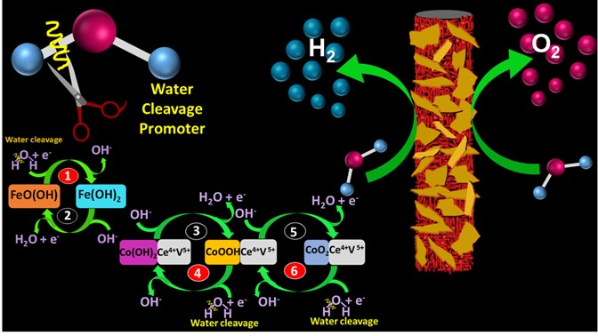

***ACS Appl. Mater. Interfaces* 2021, 13, 43, 51151–51160**